Chapter
Material Requirements Planning (MRP) and ERP

Discussion Questions
1. The difference between a gross requirements plan and a net requirement plan is that a net plan adjusts for on-hand inventory and scheduled receipts at each level.
2. Once the MRP system is in place, it provides information to assist decision makers in other functional areas such as the amounts of labor required, cash needs, purchase requirements, and timing.
3. The similarities between material requirements planning (MRP) and distribution resource planning (DRP) are that the procedures and logic are analogous.
4. The difference between material requirements planning (MRP) and material resource planning II (MRP II) is that MRP II
includes or integrates functions within the firm in addition to the management of dependent demand inventories. Examples of these additional functions include: Order entry, invoicing, billing, purchasing, production scheduling, capacity planning, and warehouse management.
5. There is no one “ideal” lot sizing technique that should be used by all manufacturing organizations. Lot-for-lot is the goal to be sought. However, where setup costs are significant and demand is not particularly lumpy, EOQ is a simple method and typically provides satisfactory results. Too much concern with lot sizing yields spurious results because of MRP dynamics.
6. In a DRP system, inventory residing within the system is moved within the system, rather than entering or leaving the system. Therefore, although effort should be made to reduce total inventory to minimize overall carrying cost, carrying cost per se does not have a significant effect on appropriate lot size.
7. MRP is usually a part of the overall production planning process. Its most important capability is including the timing/ scheduling factor in inventory planning. MRP II, of course, addresses the timing/scheduling of other resources in addition to inventory.
8. (a) When a work center is only over capacity for one week (or a short time), the production planner has a number of options, including:
- Splitting an order to an earlier or later week
- Requesting overtime, an alternate (perhaps more expensive) production process
- Subcontracting
(b) A consistent lack of capacity suggests a capital investment to increase capacity, add a shift, or develop an outside source. Redesign of the product may also be an alternative.
9. The master schedule is expressed in terms of:
(1) End items in a continuous (make-to-stock) company;
(2) Customer orders in a job shop (make-to-order) company; and
(3) Modules in a repetitive (assemble-to-stock) company.
10. Virtually all functions of the firm impact an MRP system. For instance, purchasing performance affects delivery, changes in capacity (i.e., labor, maintenance, breakdowns) impact throughput, sales impact the master schedule as do financial issues such as capital expenditure for capacity, engineering performance such as meeting schedules and preference (or flexibility) for particular approaches to design/processing.
11. The rationale for: (a) A phantom bill of material is a subassembly that exists only on the production line—say a mixture/ glue that only exists a few minutes and then must be used or discarded. Such items are never inventoried. (b) A planning bill of material may be used to issue a mixture of parts that only makes sense to reduce material handling—say the hardware for a washing machine assembly. (c) A pseudo bill of material is another name for planning bill to meet the same conditions.
12. An effective MRP system requires:
- A good schedule of what is to be made
- An accurate BOM
- Accurate inventory records
- Accurate purchases data
- Lead times that will be met
13. The benefits of ERP include:
- Provides integration of the production, supply chain, and administrative functions.
- Increases collaboration between functions and locations
- Often has a common database
- Can add effectiveness and efficiency to the organization.
14. Distinctions between MRP, DRP, and ERP, are: MRP is a
set of software programs designed to schedule material requirements. These programs include an integrated set of programs
that determine an item master for each part, a bill of material, an
explosion scheme, a lead-time file, an inventory status file, and vendor information. DRP is a time-phased stock-replenishment plan for all levels of the distribution network. Its focus is on retail and wholesale distribution network. On the other hand, enterprise resource planning (ERP) systems are systems that often integrate MRP and a variety of other accounting systems, human resource management, and communication with vendors and suppliers.
15. In MRP, demand need not be constant. Also, in an MRP system, the demand for one item depends on the demand for
others—in particular, the end item. (There are exceptions such as spare parts and maintenance orders.)
16. The disadvantages of ERP include:
- Is very expensive to purchase and even more costly to customize.
- Implementation may require major changes in the company and its processes.
- Is so complex that many companies cannot adjust to it.
- Involves an ongoing process for implementation, which may never be completed.
- Expertise in ERP is limited, with staffing an ongoing problem.
17. (a) The Web sites of most of the major ERP vendors will include “successful solutions” using their software. See Web pages of the major vendors:
American Software: www.amsoftware.com
JD Edwards: www.jdedwards.com
The Baan Company: www.baan.com
Oracle: www.oracle.com
SAP: www.sap.com
IQMS: www.iqms.com
(b) The poor ERP efforts or installations may take a little more digging, but a look at www.CIO.com and www.
Information Week.com should get students started.
18. (a) PeopleSoft includes the following in its CRM offerings (see http://www.oracle.com/applications/peoplesoft/
CRM/ent/index.html):
Supplier Relationship Management Manage supplier relationships including indirect and direct goods, as well as services procurement with:
- Partner relationship management solution
- Sales solution
- Service solution
- CRM analytics
- CRM industry solutions
- Marketing solution
(b) SAP’s Supply Chain Management product includes:
- Supply strategy development
- Supplier qualification
- Supplier selection
- Contract negotiation and management
(c) SAP’s Product Lifecycle Management product
includes:
- Life-cycle data management
- Asset life-cycle management
- Program & project management
- Life-cycle collaboration
- Quality management
- Environment health & safety
(See www.sap.com/solutions.)
19. Moving toward JIT and kanban suggest that the traditional weekly “buckets” (or even daily buckets) in an MRP system may be inadequate. MRP systems may need to move to hourly buckets for some items. Some MRP systems now deliver to “positions” in the production process—a “flow” criterion rather than a bucket criteria.
Additionally, if tracking of small lots is necessary (and it may not be) then not only will such “buckets” be necessary, but ease of inputs via bar codes or other automated means may be necessary.
Ethical Dilemma
ERP is going to cost more than expected.
What do you do? Certainly, any sense of fairness and decency suggest that the customer must be told the truth. However,
a sales representative can be expected to try to solve the problem for his customer. This may mean that:
- The first stop is the sales representative’s manager to see if another customer or pending customer may have dealt with this problem and solved the problem or may be willing to share development costs.
- A second option is to ask the manager “Is there any budget or pending budget for this type of enhancement or can we help the customer out by paying for part of the enhancement?”
The bottom line is that not telling the customer the truth and/or selling the customer something that will not do the job is not only unethical, but also probably bad business—certainly bad business in the long run.
Active Model Exercise
ACTIVE MODEL 14.1: Order Releases
1. Suppose that item B must be ordered in multiples of dozens. Which items are affected by this change?
Items D and E
2. Suppose that the minimum order quantity for item C is 200 units. Which items are affected by this change?
Items E, F, G, and D
End-of-Chapter Problems
14.1 An exploded bill yields the following:
Item J: 200 units; Item K: 200 × 1 = 200 units; Item L: 200 × 4 = 800 units; Item M: 200 × 2 = 400 units.
14.2 The time-phased assembly plan for the gift bags is:
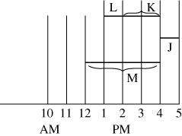
Someone should start on item M by noon.
14.3 (a) Product structure:
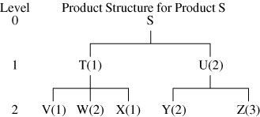
(b)
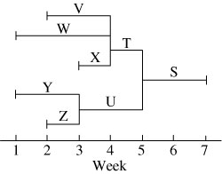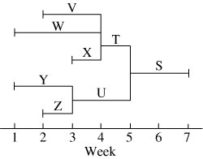

14.4 Gross material requirements plan:
Week |  |  |  |  |  |  |  |  |  | Lead Time
Item |  | 1 | 2 | 3 | 4 | 5 | 6 | 7 | 8 | (weeks)
S | Gross req |  |  |  |  |  |  | 100
 | Order release |  |  |  |  | 100 |  |  |  | 2
T | Gross req |  |  |  |  | 100
 | Order release |  |  |  | 100 |  |  |  |  | 1
U | Gross req |  |  |  |  | 200
 | Order release |  |  | 200 |  |  |  |  |  | 2
V | Gross req |  |  |  | 100
 | Order release |  | 100 |  |  |  |  |  |  | 2
W | Gross req |  |  |  | 200
 | Order release | 200 |  |  |  |  |  |  |  | 3
X | Gross req |  |  |  | 100
 | Order release |  |  | 100 |  |  |  |  |  | 1
Y | Gross req |  |  | 400
 | Order release | 400 |  |  |  |  |  |  |  | 2
Z | Gross req |  |  | 600
 | Order release |  | 600 |  |  |  |  |  |  | 1
14.5 Net material requirements plan:
 |  | Week |  |  |  |  |  |  |  | Lead Time
Item |  | 1 | 2 | 3 | 4 | 5 | 6 | 7 | 8 | (weeks)
S | Gross req |  |  |  |  |  |  | 100
 | On hand |  |  |  |  |  |  | 20
 | Net req |  |  |  |  |  |  | 80 |  | 2
 | Order receipt |  |  |  |  |  |  | 80
 | Order release |  |  |  |  | 80
T | Gross req |  |  |  |  | 80
 | On hand |  |  |  |  | 20
 | Net req |  |  |  |  | 60 |  |  |  | 1
 | Order receipt |  |  |  |  | 60
 | Order release |  |  |  | 60
U | Gross req |  |  |  |  | 160
 | On hand |  |  |  |  | 40
 | Net req |  |  |  |  | 120 |  |  |  | 2
 | Order receipt |  |  |  |  | 120
 | Order release |  |  | 120
V | Gross req |  |  |  | 60
 | On hand |  |  |  | 30
 | Net req |  |  |  | 30 |  |  |  |  | 2
 | Order receipt |  |  |  | 30
 | Order release |  | 30

14.6 Gross material requirements plan, modified to include the 20 units of U required for maintenance purposes:
 |  | Week |  |  |  |  |  |  |  | Lead Time
Item |  | 1 | 2 | 3 | 4 | 5 | 6 | 7 | 8 | (weeks)
W | Gross req |  |  |  | 120
 | On hand |  |  |  | 30
 | Net req |  |  |  | 90 |  |  |  |  | 3
 | Order receipt |  |  |  | 90
 | Order release | 90
X | Gross req |  |  |  | 60
 | On hand |  |  |  | 25
 | Net req |  |  |  | 35 |  |  |  |  | 1
 | Order receipt |  |  |  | 35
 | Order release |  |  | 35
Y | Gross req |  |  | 240
 | On hand |  |  | 240
 | Net req |  |  | 0 |  |  |  |  |  | 2
 | Order receipt |  |  | 0
 | Order release
Z | Gross req |  |  | 360
 | On hand |  |  | 40
 | Net req |  |  | 320 |  |  |  |  |  | 1
 | Order receipt |  |  | 320
 | Order release |  | 320
14.7 Net material requirements plan, modified to include the
20 units of U required for maintenance:
 |  | Week |  |  |  |  |  |  |  |  | Lead Time
Item |  | 1 | 2 | 3 | 4 | 5 | 6 |  | 7 | 8 | (weeks)
S | Gross req |  |  |  |  |  |  |  | 100
 | Order release |  |  |  |  | 100 |  |  |  |  | 2
T | Gross req |  |  |  |  | 100
 | Order release |  |  |  | 100 |  |  |  |  |  | 1
U | Gross req |  |  |  |  | 200 | 20*
 | Order release |  |  | 200 | 20 |  |  |  |  |  | 2
V | Gross req |  |  |  | 100
 | Order release |  | 100 |  |  |  |  |  |  |  | 2
W | Gross req |  |  |  | 200
 | Order release | 200 |  |  |  |  |  |  |  |  | 3
X | Gross req |  |  |  | 100
 | Order release |  |  | 100 |  |  |  |  |  |  | 1
Y | Gross req |  |  | 400 | 40
 | Order release | 400 | 40 |  |  |  |  |  |  |  | 2
Z | Gross req |  |  | 600 | 60
 | Order release |  | 600 | 60 |  |  |  |  |  |  | 1
*needed for maintenance.
 |  | Week |  |  |  |  |  |  |  |  | Lead Time
Item |  | 1 | 2 | 3 | 4 | 5 | 6 | 7 |  | 8 | (weeks)
S | Gross req |  |  |  |  |  |  | 100
 | On hand |  |  |  |  |  |  | 20
 | Net req |  |  |  |  |  |  | 80 |  |  | 2
 | Order receipt |  |  |  |  |  |  | 80
 | Order release |  |  |  |  | 80
T | Gross req |  |  |  |  | 80
 | On hand |  |  |  |  | 20
 | Net req |  |  |  |  | 60 |  |  |  |  | 1
 | Order receipt |  |  |  |  | 60
 | Order release |  |  |  | 60

 |  | Week |  |  |  |  |  |  |  |  | Lead Time
Item |  | 1 | 2 | 3 | 4 | 5 | 6 | 7 |  | 8 | (weeks)
U | Gross req |  |  |  |  | 160 | 20*
 | On hand |  |  |  |  | 40 | 0
 | Net req |  |  |  |  | 120 | 20 |  |  |  | 2
 | Order receipt |  |  |  |  | 120 | 20
 | Order release |  |  | 120 | 20
V | Gross req |  |  |  | 60
 | On hand |  |  |  | 30
 | Net req |  |  |  | 30 |  |  |  |  |  | 2
 | Order receipt |  |  |  | 30
 | Order release |  | 30
W | Gross req |  |  |  | 120
 | On hand |  |  |  | 30
 | Net req |  |  |  | 90 |  |  |  |  |  | 3
 | Order receipt |  |  |  | 90
 | Order release | 90
X | Gross req |  |  |  | 60
 | On hand |  |  |  | 25
 | Net req |  |  |  | 35 |  |  |  |  |  | 1
 | Order receipt |  |  |  | 35
 | Order release |  |  | 35
Y | Gross req |  |  | 240 | 40
 | On hand |  |  | 240 | 0
 | Net req |  |  |  | 40 |  |  |  |  |  | 2
 | Order receipt |  |  |  | 40
 | Order release |  | 40
Z | Gross req |  |  | 360 | 60
 | On hand |  |  | 40 | 0
 | Net req |  |  | 320 | 60 |  |  |  |  |  | 1
 | Order receipt |  |  | 320 | 60
 | Order release |  | 320 | 60
* To achieve these results in POM for Windows, add Part U as a new BOM line, level O, so that the software will recognize an additional independent demand, not scheduled receipts.

Level
0

1

2

3
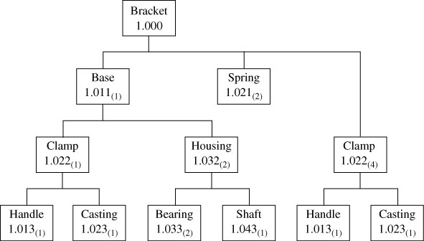
14.8 (a)

(b) For 50 brackets, the gross requirements are for 50 bases, 100 springs, 250 clamps, 250 handles, 250 castings, 100 housings, 200 bearings, and 100 shafts.
(c) For 50 brackets net requirements are: 25 bases, 100 springs, 125 clamps, 125 handles, 125 castings, 50 housings, 100 bearings, and 50 shafts.
14.9 (a) Time-phased product structure for bracket with start times:
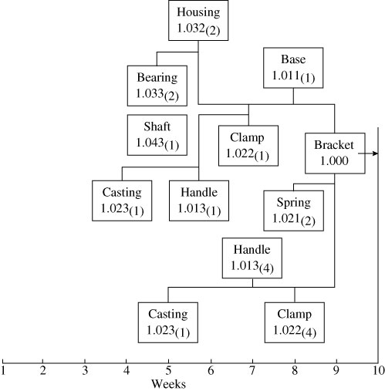

(b) Castings need to start in week 4.
14.10 (a) Gross material requirements plan:
Note: Elements have been listed in the gross material requirements plan in the order of level, and within a level, from left to right as viewed in the product structure.
Week
Item |  |  | 1 |  | 2 |  | 3 |  | 4 |  | 5 |  | 6 |  | 7 |  | 8 |  | 9 |  | 10 |  | 11 |  | 12
X₁ |  | Gross req |  |  |  |  |  |  |  |  |  |  |  |  |  |  | 50 |  |  |  | 20 |  |  |  | 100
 |  | Order rel |  |  |  |  |  |  |  |  |  |  |  |  | 50 |  |  |  | 20 |  |  |  | 100
B₁ |  | Gross req |  |  |  |  |  |  |  |  |  |  |  |  | 50 |  |  |  | 20 |  |  |  | 100
 |  | Order rel |  |  |  |  |  |  |  |  | 50 |  |  |  | 20 |  |  |  | 100
B₂ |  | Gross req |  |  |  |  |  |  |  |  |  |  |  |  | 100 |  |  |  | 40 |  |  |  | 200
 |  | Order rel |  |  |  |  |  |  |  |  | 100 |  |  |  | 40 |  |  |  | 200
A₁ |  | Gross req |  |  |  |  |  |  |  |  | 50 |  |  |  | 20 |  |  |  | 100
 |  | Order rel |  |  |  |  |  |  | 50 |  |  |  | 20 |  |  |  | 100
C |  | Gross req |  |  |  |  |  |  |  |  | 200 |  |  |  | 80 |  |  |  | 400
 |  | Order rel |  |  |  |  |  |  | 200 |  |  |  | 80 |  |  |  | 400
D | Gross req |  |  |  |  |  |  |  |  |  |  | 100 |  |  |  | 40 |  |  |  | 200
 | Order rel |  |  |  |  |  |  |  |  | 100 |  |  |  | 40 |  |  |  | 200
E | Gross req |  |  |  |  |  |  |  |  | 200 |  | 50 |  | 80 |  | 20 |  | 400 |  | 100
 | Order rel |  |  | 200 |  | 50 |  | 80 |  | 20 |  | 400 |  | 100

(b) Net material requirements (planned order release) plan:
Level: 0 |  |  | Parent:— |  |  |  |  |  |  | Quantity:
Item: X1 |  |  | Lead Time: 1 |  |  |  |  |  |  | Lot Size: L4L
Week No. | 1 | 2 |  | 3 | 4 | 5 | 6 | 7 | 8 |  | 9 | 10 | 11 | 12
Gross
requirement |  |  |  |  |  |  |  |  | 50 |  |  | 20 |  | 100
Scheduled
receipt
On hand 50 |  |  |  |  |  |  |  |  | 50 |  |  | 0 |  | 0
Net
requirement |  |  |  |  |  |  |  |  | 0 |  |  | 20 |  | 100
Planned order
receipt |  |  |  |  |  |  |  |  |  |  |  | 20 |  | 100
Planned order
release |  |  |  |  |  |  |  |  |  |  | 20 |  | 100

Level: 1 | Parent: X1 |  |  |  |  |  | Quantity: 1X
Item: B1 | Lead Time: 2 |  |  |  |  |  | Lot Size: L4L
Week No. | 1 | 2 | 3 | 4 | 5 | 6 | 7 | 8 | 9 | 10 | 11 | 12
Gross requirement |  |  |  |  |  |  |  |  | 20 |  | 100
Scheduled receipt
On hand 20 |  |  |  |  |  |  |  |  | 20 |  | 0
Net requirement |  |  |  |  |  |  |  |  | 0 |  | 100
Planned order receipt |  |  |  |  |  |  |  |  |  |  | 100
Planned order release |  |  |  |  |  |  |  |  | 100

Level: 1 | Parent: X1 |  |  |  |  |  | Quantity: 2X
Item: B2 | Lead Time: 2 |  |  |  |  |  | Lot Size: L4L
Week No. | 1 | 2 | 3 | 4 | 5 | 6 | 7 | 8 | 9 | 10 | 11 | 12
Gross requirement |  |  |  |  |  |  |  |  | 40 |  | 200
Scheduled receipt
On hand 20 |  |  |  |  |  |  |  |  | 20 |  | 0
Net requirement |  |  |  |  |  |  |  |  | 20 |  | 200
Planned order receipt |  |  |  |  |  |  |  |  | 20 |  | 200
Planned order release |  |  |  |  |  |  | 20 |  | 200

Level: 2 | Parent: B1 |  |  |  |  |  | Quantity: 1X
Item: A1 | Lead Time: 1 |  |  |  |  |  | Lot Size: L4L
Week No. | 1 | 2 | 3 | 4 | 5 | 6 | 7 | 8 | 9 | 10 | 11 | 12
Gross requirement |  |  |  |  |  |  |  |  | 100
Scheduled receipt
On hand 5 |  |  |  |  |  |  |  |  | 5
Net requirement |  |  |  |  |  |  |  |  | 95
Planned order receipt |  |  |  |  |  |  |  |  | 95
Planned order release |  |  |  |  |  |  |  | 95

Level: 2 | Parent: B2 |  |  |  |  |  | Quantity: 2X
Item: C | Lead Time: 1 |  |  |  |  |  | Lot Size: L4L
Week No. | 1 | 2 | 3 | 4 | 5 | 6 | 7 | 8 | 9 | 10 | 11 | 12
Gross requirement |  |  |  |  |  |  | 40 |  | 400
Scheduled receipt
On hand |  |  |  |  |  |  | 0 |  | 0
Net requirement |  |  |  |  |  |  | 40 |  | 400
Planned order receipt |  |  |  |  |  |  | 40 |  | 400
Planned order release |  |  |  |  |  | 40 |  | 400

Level: 2 | Parent: B2 |  |  |  |  |  | Quantity: 1X
Item: D | Lead Time: 1 |  |  |  |  |  | Lot Size: L4L
Week No. | 1 | 2 | 3 | 4 | 5 | 6 | 7 | 8 | 9 | 10 | 11 | 12
Gross requirement |  |  |  |  |  |  | 20 |  | 200
Scheduled receipt
On hand |  |  |  |  |  |  | 0 |  | 0
Net requirement |  |  |  |  |  |  | 20 |  | 200
Planned order receipt |  |  |  |  |  |  | 20 |  | 200
Planned order release |  |  |  |  |  | 20 |  | 200

Level: 2&3 | Parent: B1 & D |  |  |  |  |  | Quantity: 1X & 2X
Item: E | Lead Time: 2 |  |  |  |  |  | Lot Size: L4L
Week No. | 1 | 2 | 3 | 4 | 5 | 6 | 7 | 8 | 9 | 10 | 11 | 12
Gross requirement |  |  |  |  |  | 40 |  | 400 | 100
Scheduled receipt
On hand |  |  |  |  |  | 10 |  | 0 | 0
Net requirement 10 |  |  |  |  |  | 30 |  | 400 | 100
Planned order receipt |  |  |  |  |  | 30 |  | 400 | 100
Planned order release |  |  | 30 |  | 400 | 100

14.11 (a)
 |  |  |  |  |  | Week
Item |  | 1 | 2 | 3 | 4 | 5 | 6 | 7 | 8 | 9 | 10 | 11 | 12
A | Gross req |  |  |  |  |  |  |  | 100 |  | 50 |  | 150
 | Order rel |  |  |  |  |  |  | 100 |  | 50 |  | 150
H | Gross req |  |  |  |  |  |  |  |  | 100 |  | 50
 | Order rel |  |  |  |  |  |  |  | 100 |  | 50
C | Gross req |  |  |  |  |  |  | 100 | 100 | 50 | 50 | 150
 | Order rel |  |  |  |  | 100 | 100 | 50 | 50 | 150

Level: 0 | Parent: — |  |  |  |  |  | Quantity:
Item: A | Lead Time: 1 |  |  |  |  |  | Lot Size: L4L
Week No. | 1 | 2 | 3 | 4 | 5 | 6 | 7 | 8 | 9 | 10 | 11 | 12
Gross requirement |  |  |  |  |  |  |  | 100 |  | 50 |  | 150
Scheduled receipt
On hand |  |  |  |  |  |  |  | 0 |  | 0 |  | 0
Net requirement |  |  |  |  |  |  |  | 100 |  | 50 |  | 150
Planned order receipt |  |  |  |  |  |  |  | 100 |  | 50 |  | 150
Planned order release |  |  |  |  |  |  | 100 |  | 50 |  | 150

Level: 0 | Parent: — |  |  |  |  |  | Quantity:
Item: H | Lead Time: 1 |  |  |  |  |  | Lot Size: L4L
Week No. | 1 | 2 | 3 | 4 | 5 | 6 | 7 | 8 | 9 | 10 | 11 | 12
Gross requirement |  |  |  |  |  |  |  |  | 100 |  | 50
Scheduled receipt
On hand |  |  |  |  |  |  |  |  | 0 |  | 0
Net requirement |  |  |  |  |  |  |  |  | 100 |  | 50
Planned order receipt |  |  |  |  |  |  |  |  | 100 |  | 50
Planned order release |  |  |  |  |  |  |  | 100 |  | 50

Level: 1 | Parent: A, H |  |  |  |  |  | Quantity: 1X
Item: C | Lead Time: 2 |  |  |  |  |  | Lot Size: L4L
Week No. | 1 | 2 | 3 | 4 | 5 | 6 | 7 | 8 | 9 | 10 | 11 | 12
Gross requirement |  |  |  |  |  |  | 100 | 100 | 50 | 50 | 150
Scheduled receipt
On hand |  |  |  |  |  |  | 50 | 0 | 0 | 0 | 0
Net requirement 50 |  |  |  |  |  |  | 50 | 100 | 50 | 50 | 150
Planned order receipt |  |  |  |  |  |  | 50 | 100 | 50 | 50 | 150
Planned order release |  |  |  |  | 50 | 100 | 50 | 50 | 150

(b)

14.12 (a) Net material requirements plan:
 |  |  | Week
Item |  |  | 1 | 2 | 3 | 4 | 5 | 6 | 7 | 8 | 9 | 10 | 11 | 12
A | Gross requirement |  |  |  |  |  |  |  |  | 100 |  | 50 |  | 150
 | On hand: — | 0 |  |  |  |  |  |  |  | 0 |  | 0 |  | 0
 | Net requirement |  |  |  |  |  |  |  |  | 100 |  | 50 |  | 150
 | Order receipt |  |  |  |  |  |  |  |  | 100 |  | 50 |  | 150
 | Order release |  |  |  |  |  |  |  | 100 |  | 50 |  | 150
H | Gross requirement |  |  |  |  |  |  |  |  |  | 100 |  | 50
 | On hand: — | 0 |  |  |  |  |  |  |  |  | 0 |  | 0
 | Net requirement |  |  |  |  |  |  |  |  |  | 100 |  | 50
 | Order receipt |  |  |  |  |  |  |  |  |  | 100 |  | 50
 | Order release |  |  |  |  |  |  |  |  | 100 |  | 50
B | Gross requirement |  |  |  |  |  |  |  | 100 |  | 50 |  | 150
 | On hand: | 100 |  |  |  |  |  |  | 100 |  | 0 |  | 0
 | Net requirement |  |  |  |  |  |  |  |  |  | 50 |  | 150
 | Order receipt |  |  |  |  |  |  |  |  |  | 50 |  | 150
 | Order release |  |  |  |  |  |  |  | 50 |  | 150
C | Gross requirement |  |  |  |  |  |  |  | 100 | 100 | 50 | 50 | 150
 | On hand: | 50 |  |  |  |  |  |  | 50 | 0 | 0 | 0 | 0
 | Net requirement |  |  |  |  |  |  |  | 50 | 100 | 50 | 50 | 150
 | Order receipt |  |  |  |  |  |  |  | 50 | 100 | 50 | 50 | 150
 | Order release |  |  |  |  |  | 50 | 100 | 50 | 50 | 150
J | Gross requirement |  |  |  |  |  |  |  |  | 100 |  | 50
 | On hand: | 100 |  |  |  |  |  |  |  | 100 |  | 0
 | Net requirement |  |  |  |  |  |  |  |  | 0 |  | 50
 | Order receipt |  |  |  |  |  |  |  |  | 0 |  | 50
 | Order release |  |  |  |  |  |  |  |  | 50
K | Gross requirement |  |  |  |  |  |  |  |  | 100 |  | 50
 | On hand: | 100 |  |  |  |  |  |  |  | 100 |  | 0
 | Net requirement |  |  |  |  |  |  |  |  | 0 |  | 50
 | Order receipt |  |  |  |  |  |  |  |  | 0 |  | 50
 | Order release |  |  |  |  |  |  |  |  | 50
D | Gross requirement |  |  |  |  |  |  |  | 50 |  | 150
 | On hand: | 50 |  |  |  |  |  |  | 50 |  | 0
 | Net requirement |  |  |  |  |  |  |  |  |  | 150
 | Order receipt |  |  |  |  |  |  |  |  |  | 150
 | Order release |  |  |  |  |  |  |  |  | 150
E | Gross requirement |  |  |  |  |  |  |  | 50 | 100 | 150
 | On hand: | 75 |  |  |  |  |  |  | 75 | 25 | 0
 | Net requirement |  |  |  |  |  |  |  |  | 75 | 150
 | Order receipt |  |  |  |  |  |  |  |  | 75 | 150
 | Order release |  |  |  |  |  |  | 75 | 150
F | Gross requirement |  |  |  |  |  | 50 | 100 | 50 | 100 | 150
 | On hand: | 75 |  |  |  |  | 75 | 25 | 0 | 0 | 0
 | Net requirement |  |  |  |  |  |  | 75 | 50 | 100 | 150
 | Order receipt |  |  |  |  |  |  | 75 | 50 | 100 | 150
 | Order release |  |  |  |  | 75 | 50 | 100 | 150
G | Gross requirement |  |  |  |  |  | 50 | 100 | 50 | 100 | 150
 | On hand: | 75 |  |  |  |  | 75 | 25 | 0 | 0 | 0
 | Net requirement |  |  |  |  |  |  | 75 | 50 | 100 | 150
 | Order receipt |  |  |  |  |  |  | 75 | 50 | 100 | 150
 | Order release |  |  |  |  |  | 75 | 50 | 100 | 150

(b)
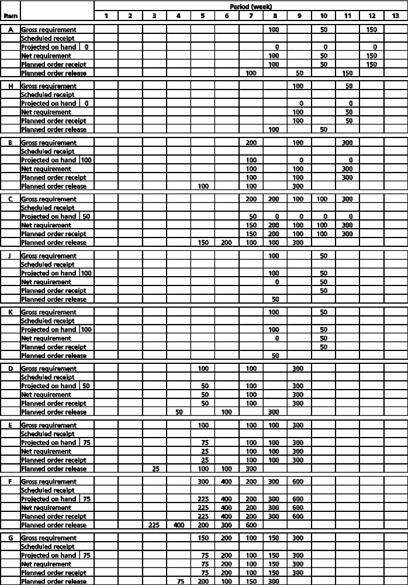

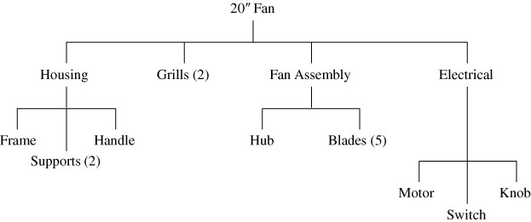
14.13 (a)

(b)
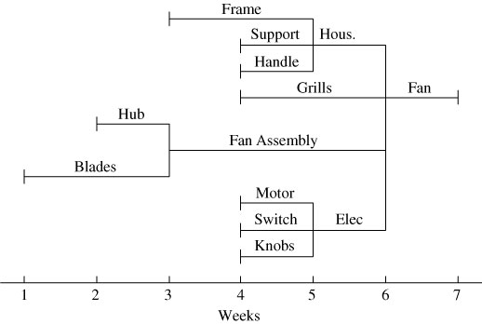

(c)
Level: 0 | Parent: — |  |  |  |  |  | Quantity:
Item: 20″ fan | Lead Time: 1 |  |  |  |  |  | Lot Size:
Week No. | 1 | 2 | 3 | 4 | 5 | 6 | 7 | 8 | 9 | 10 | 11 | 12
Gross requirement |  |  |  |  |  |  | 1,000
Scheduled receipt
On hand 100 |  |  |  |  |  |  | 100
Net requirement |  |  |  |  |  |  | 900
Planned order receipt |  |  |  |  |  |  | 900
Planned order release |  |  |  |  |  | 900

Level: 1 |  | Parent: 20″ fan |  |  |  |  |  | Quantity: 1X
Item: housing |  | Lead Time: 1 week |  |  |  |  |  | Lot Size: L4L
Week No. | 1 |  | 2 | 3 | 4 | 5 | 6 | 7 | 8 | 9 | 10 | 11 | 12
Gross requirement |  |  |  |  |  |  | 900
Scheduled receipt
On hand 100 |  |  |  |  |  |  | 100
Net requirement |  |  |  |  |  |  | 800
Planned order receipt |  |  |  |  |  |  | 800
Planned order release |  |  |  |  |  | 800

Level: 1 |  | Parent: 20″ fan |  |  |  |  |  |  | Quantity: 2X
Item: grills |  | Lead Time: 2 weeks |  |  |  |  |  |  | Lot Size: 500
Week No. | 1 |  | 2 | 3 | 4 | 5 |  | 6 | 7 | 8 | 9 | 10 | 11 | 12
Gross requirement |  |  |  |  |  |  |  | 1,800
Scheduled receipt
On hand 200 |  |  |  |  |  |  |  | 200 | 400
Net requirement |  |  |  |  |  |  |  | 1,600
Planned order receipt |  |  |  |  |  |  |  | 2,000
Planned order release |  |  |  |  | 2,000

Level: 1 | Parent: 20″ fan |  |  |  |  |  |  | Quantity: 1X
Item: fan assembly | Lead Time: 3 weeks |  |  |  |  |  |  | Lot Size: L4L
Week No. | 1 | 2 | 3 | 4 |  | 5 | 6 | 7 | 8 | 9 | 10 | 11 | 12
Gross requirement |  |  |  |  |  |  | 900
Scheduled receipt
On hand 150 |  |  |  |  |  |  | 150
Net requirement |  |  |  |  |  |  | 750
Planned order receipt |  |  |  |  |  |  | 750
Planned order release |  |  | 750

Level: 1 | Parent: 20″ fan |  |  |  |  |  | Quantity: 1X
Item: electrical unit | Lead Time: 1 week |  |  |  |  |  | Lot Size: L4L
Week No. | 1 | 2 | 3 | 4 | 5 | 6 | 7 | 8 | 9 | 10 | 11 | 12
Gross requirement |  |  |  |  |  | 900
Scheduled receipt
On hand
Net requirement |  |  |  |  |  | 900
Planned order receipt |  |  |  |  |  | 900
Planned order release |  |  |  |  | 900

Level: 2 | Parent: housing |  |  |  |  |  | Quantity: 1X
Item: frame | Lead Time: 2 weeks |  |  |  |  |  | Lot Size: L4L
Week No. | 1 | 2 | 3 | 4 | 5 | 6 | 7 | 8 | 9 | 10 | 11 | 12
Gross requirement |  |  |  |  | 800
Scheduled receipt
On hand
Net requirement |  |  |  |  | 800
Planned order receipt |  |  |  |  | 800
Planned order release |  |  | 800

Level: 2 | Parent: housing |  |  |  |  |  | Quantity: 2X
Item: supports | Lead Time: 1 week |  |  |  |  |  | Lot Size: 100
Week No. | 1 | 2 | 3 | 4 | 5 | 6 | 7 | 8 | 9 | 10 | 11 | 12
Gross requirement |  |  |  |  | 1,600
Scheduled receipt
On hand |  |  |  |  | 50
Net requirement |  |  |  |  | 1,550
Planned order receipt |  |  |  |  | 1,600
Planned order release |  |  |  | 1,600

Level: 2 | Parent: housing |  |  |  |  |  | Quantity: 1X
Item: handle | Lead Time: 1 week |  |  |  |  |  | Lot Size: 500
Week No. | 1 | 2 | 3 | 4 | 5 | 6 | 7 | 8 | 9 | 10 | 11 | 12
Gross requirement |  |  |  |  | 800
Scheduled receipt
On hand |  |  |  |  | 400 | 100
Net requirement |  |  |  |  | 400
Planned order receipt |  |  |  |  | 500
Planned order release |  |  |  | 500

Level: 2 | Parent: fan assembly |  |  |  |  |  | Quantity: 1X
Item: hub | Lead Time: 1 week |  |  |  |  |  | Lot Size: L4L
Week No. | 1 | 2 | 3 | 4 | 5 | 6 | 7 | 8 | 9 | 10 | 11 | 12
Gross requirement |  |  | 750
Scheduled receipt
On hand
Net requirement |  |  | 750
Planned order receipt |  |  | 750
Planned order release |  | 750

Level: 2 | Parent: fan assembly |  |  |  |  |  | Quantity: 5X
Item: blades | Lead Time: 2 weeks |  |  |  |  |  | Lot Size: 100
Week No. | 1 | 2 | 3 | 4 | 5 | 6 | 7 | 8 | 9 | 10 | 11 | 12
Gross requirement |  |  | 3,750
Scheduled receipt
On hand |  |  |  | 50
Net requirement |  |  | 3,750
Planned order receipt |  |  | 3,800
Planned order release | 3,800

Level: 2 | Parent: electrical unit |  |  |  |  |  | Quantity: 1X
Item: motor | Lead Time: 1 week |  |  |  |  |  | Lot Size: L4L
Week No. | 1 | 2 | 3 | 4 | 5 | 6 | 7 | 8 | 9 | 10 | 11 | 12
Gross requirement |  |  |  |  | 900
Scheduled receipt
On hand
Net requirement |  |  |  |  | 900
Planned order receipt |  |  |  |  | 900
Planned order release |  |  |  | 900

Level: 2 | Parent: electrical unit |  |  |  |  |  | Quantity: 1X
Item: switch | Lead Time: 1 week |  |  |  |  |  | Lot Size: 12
Week No. | 1 | 2 | 3 | 4 | 5 | 6 | 7 | 8 | 9 | 10 | 11 | 12
Gross requirement |  |  |  |  | 900
Scheduled receipt
On hand 20 |  |  |  |  | 20 | 8
Net requirement |  |  |  |  | 880
Planned order receipt |  |  |  |  | 888
Planned order release |  |  |  | 888

Level: 2 | Parent: electrical unit |  |  |  |  |  | Quantity: 1X
Item: knob | Lead Time: 1 week |  |  |  |  |  | Lot Size: 25
Week No. | 1 | 2 | 3 | 4 | 5 | 6 | 7 | 8 | 9 | 10 | 11 | 12
Gross requirement |  |  |  |  | 900
Scheduled receipt |  | 200
On hand |  |  | 200 | 200 | 200
Net requirement
Planned order receipt |  |  |  |  | 700
Planned order release |  |  |  | 700

Level |  | Component |  |  | Quantity
0 | A |  |  |  | 1
1 |  | B |  |  | 1
2 |  |  | C |  | 1
2 |  |  | D |  | 1
3 |  |  |  | E | 1
1 |  | F |  |  | 1
2 |  |  | G |  | 1
2 |  |  | H |  | 1
3 |  |  |  | E | 1
3 |  |  |  | C | 1
Note: with low-level coding, C would be a level 3 code.

14.14 (a)

(b)
 |  |  |  |  | Low
Lot | Lead | On | Safety |  | Level | Item |  |  |  | Period (week)
Size | Time | Hand | Stock | Allocated | Code | ID |  | 1 | 2 | 3 | 4 | 5 | 6 | 7 | 8
Lot | 1 | 0 | — | — | 0 | A | Gross requirement |  |  |  |  |  |  |  | 10
for |  |  |  |  |  |  | Scheduled receipt
Lot |  |  |  |  |  |  | Projected on hand |  |  |  |  |  |  |  | 0
 |  |  |  |  |  |  | Net requirement |  |  |  |  |  |  |  | 10
 |  |  |  |  |  |  | Planned receipt |  |  |  |  |  |  |  | 10
 |  |  |  |  |  |  | Planned release |  |  |  |  |  |  | 10

 |  |  |  |  | Low
Lot | Lead | On | Safety |  | Level | Item |  |  |  | Period (week)
Size | Time | Hand | Stock | Allocated | Code | ID |  | 1 | 2 | 3 | 4 | 5 | 6 | 7 | 8
Lot | 1 | 2 | — | — | 1 | B | Gross requirement |  |  |  |  |  |  | 10^{A}
for |  |  |  |  |  |  | Scheduled receipt
Lot |  |  |  |  |  |  | Projected on hand | 2 | 2 | 2 | 2 | 2 | 2 | 2 | 0
 |  |  |  |  |  |  | Net requirement |  |  |  |  |  |  | 8
 |  |  |  |  |  |  | Planned receipt |  |  |  |  |  |  | 8
 |  |  |  |  |  |  | Planned release |  |  |  |  |  | 8

 |  |  |  |  | Low
Lot | Lead | On | Safety |  | Level | Item |  |  |  | Period (week)
Size | Time | Hand | Stock | Allocated | Code | ID |  | 1 | 2 | 3 | 4 | 5 | 6 | 7 | 8
Lot | 1 | 5 | — | — | 1 | F | Gross requirement |  |  |  |  |  |  | 10^{A}
for |  |  |  |  |  |  | Scheduled receipt
Lot |  |  |  |  |  |  | Projected on hand | 5 | 5 | 5 | 5 | 5 | 5 | 5 | 0
 |  |  |  |  |  |  | Net requirement |  |  |  |  |  |  | 5
 |  |  |  |  |  |  | Planned receipt |  |  |  |  |  |  | 5
 |  |  |  |  |  |  | Planned release |  |  |  |  |  | 5

 |  |  |  |  | Low
Lot | Lead | On | Safety |  | Level | Item |  |  |  | Period (week)
Size | Time | Hand | Stock | Allocated | Code | ID |  | 1 | 2 | 3 | 4 | 5 | 6 | 7 | 8
Lot | 1 | 5 | — | — | 2 | D | Gross requirement |  |  |  |  |  | 8^{B}
for |  |  |  |  |  |  | Scheduled receipt
Lot |  |  |  |  |  |  | Projected on hand | 5 | 5 | 5 | 5 | 5 | 5 | 0 | 0
 |  |  |  |  |  |  | Net requirement |  |  |  |  |  | 3
 |  |  |  |  |  |  | Planned receipt |  |  |  |  |  | 3
 |  |  |  |  |  |  | Planned release |  |  |  |  | 3

 |  |  |  |  | Low
Lot | Lead | On | Safety |  | Level | Item |  |  |  | Period (week)
Size | Time | Hand | Stock | Allocated | Code | ID |  | 1 | 2 | 3 | 4 | 5 | 6 | 7 | 8
Lot | 3 | 1 | — | — | 2 | G | Gross requirement |  |  |  |  |  | 5^{F}
for |  |  |  |  |  |  | Scheduled receipt
Lot |  |  |  |  |  |  | Projected on hand | 1 | 1 | 1 | 1 | 1 | 1 | 0 | 0
 |  |  |  |  |  |  | Net requirement |  |  |  |  |  | 4
 |  |  |  |  |  |  | Planned receipt |  |  |  |  |  | 4
 |  |  |  |  |  |  | Planned release |  |  | 4

 |  |  |  |  | Low
Lot | Lead | On | Safety |  | Level | Item |  |  |  | Period (week)
Size | Time | Hand | Stock | Allocated | Code | ID |  | 1 | 2 | 3 | 4 | 5 | 6 | 7 | 8
Lot | 1 | 10 | — | — | 2 | H | Gross requirement |  |  |  |  |  | 5^{F}
for |  |  |  |  |  |  | Scheduled receipt
Lot |  |  |  |  |  |  | Projected on hand | 10 | 10 | 10 | 10 | 10 | 10 | 5 | 5
 |  |  |  |  |  |  | Net requirement |  |  |  |  |  | 0
 |  |  |  |  |  |  | Planned receipt |  |  |  |  |  | 0
 |  |  |  |  |  |  | Planned release |  |  |  |  | 0

 |  |  |  |  | Low
Lot | Lead | On | Safety |  | Level | Item |  |  |  | Period (week)
Size | Time | Hand | Stock | Allocated | Code | ID |  | 1 | 2 | 3 | 4 | 5 | 6 | 7 | 8
Lot | 2 | 10 | — | — | 3 | C | Gross requirement |  |  |  |  | 0^{H} | 8^{B}
for |  |  |  |  |  |  | Scheduled receipt
Lot |  |  |  |  |  |  | Projected on hand | 10 | 10 | 10 | 10 | 10 | 10 | 2 | 2
 |  |  |  |  |  |  | Net requirement |  |  |  |  | 0 | 0
 |  |  |  |  |  |  | Planned receipt |  |  |  |  | 0 | 0
 |  |  |  |  |  |  | Planned release |  |  | 0 | 0

 |  |  |  |  | Low
Lot | Lead | On | Safety |  | Level | Item |  |  |  | Period (week)
Size | Time | Hand | Stock | Allocated | Code | ID |  | 1 | 2 | 3 | 4 | 5 | 6 | 7 | 8
Lot | 1 | 4 | — | — | 3 | E | Gross requirement |  |  |  |  | 3^{H,D}
for |  |  |  |  |  |  | Scheduled receipt
Lot |  |  |  |  |  |  | Projected on hand | 4 | 4 | 4 | 4 | 4 | 1 | 1 | 1
 |  |  |  |  |  |  | Net requirement |  |  |  |  | 0
 |  |  |  |  |  |  | Planned receipt |  |  |  |  | 0
 |  |  |  |  |  |  | Planned release |  |  |  | 0
Ten units are required for production, and 10 each of B and F for field service repair
Component | Quantity
A | 10
B | 20
C | 40
D | 20
E | 40
F | 20
G | 20
H | 20

 |  |  |  |  | Low
Lot | Lead | On | Safety |  | Level | Item |  |  |  | Period (week)
Size | Time | Hand | Stock | Allocated | Code | ID |  | 1 | 2 | 3 | 4 | 5 | 6 | 7 | 8
Lot | 1 | 0 | — | — | 0 | A | Gross requirement |  |  |  |  |  |  |  | 10
for |  |  |  |  |  |  | Scheduled receipt
Lot |  |  |  |  |  |  | Projected on hand | 0 | 0 | 0 | 0 | 0 | 0 | 0 | 10
 |  |  |  |  |  |  | Net requirement |  |  |  |  |  |  |  | 10
 |  |  |  |  |  |  | Planned receipt |  |  |  |  |  |  |  | 10
 |  |  |  |  |  |  | Planned release |  |  |  |  |  |  | 10

 |  |  |  |  | Low
Lot | Lead | On | Safety |  | Level | Item |  |  |  | Period (week)
Size | Time | Hand | Stock | Allocated | Code | ID |  | 1 | 2 | 3 | 4 | 5 | 6 | 7 | 8
Lot | 1 | 2 | — | — | 1 | B | Gross requirement |  |  |  |  |  | 10^{M} | 10^{A}
for |  |  |  |  |  |  | Scheduled receipt
Lot |  |  |  |  |  |  | Projected on hand | 2 | 2 | 2 | 2 | 2 | 2 | 0 | 0
 |  |  |  |  |  |  | Net requirement |  |  |  |  |  | 8 | 10
 |  |  |  |  |  |  | Planned receipt |  |  |  |  |  | 8 | 10
 |  |  |  |  |  |  | Planned release |  |  |  |  | 8 | 10

14.15 (a)

(b)

 |  |  |  |  | Low
Lot | Lead | On | Safety |  | Level | Item |  |  |  | Period (week)
Size | Time | Hand | Stock | Allocated | Code | ID |  | 1 | 2 | 3 | 4 | 5 | 6 | 7 | 8
Lot | 1 | 5 | — | — | 1 | F | Gross requirement |  |  |  |  |  | 10^{M} | 10^{A}
for |  |  |  |  |  |  | Scheduled receipt
Lot |  |  |  |  |  |  | Projected on hand | 5 | 5 | 5 | 5 | 5 | 5 | 0 | 0
 |  |  |  |  |  |  | Net requirement |  |  |  |  |  | 5 | 10
 |  |  |  |  |  |  | Planned receipt |  |  |  |  |  | 5 | 10
 |  |  |  |  |  |  | Planned release |  |  |  |  | 5 | 10

 |  |  |  |  | Low
Lot | Lead | On | Safety |  | Level | Item |  |  |  | Period (week)
Size | Time | Hand | Stock | Allocated | Code | ID |  | 1 | 2 | 3 | 4 | 5 | 6 | 7 | 8
Lot | 1 | 5 | — | — | 2 | D | Gross requirement |  |  |  |  | 8^{B} | 10^{B}
for |  |  |  |  |  |  | Scheduled receipt
Lot |  |  |  |  |  |  | Projected on hand | 5 | 5 | 5 | 5 | 5 | 0 | 0 | 0
 |  |  |  |  |  |  | Net requirement |  |  |  |  | 3 | 10
 |  |  |  |  |  |  | Planned receipt |  |  |  |  | 3 | 10
 |  |  |  |  |  |  | Planned release |  |  |  | 3 | 10

 |  |  |  |  | Low
Lot | Lead | On | Safety |  | Level | Item |  |  |  | Period (week)
Size | Time | Hand | Stock | Allocated | Code | ID |  | 1 | 2 | 3 | 4 | 5 | 6 | 7 | 8
Lot | 3 | 1 | — | — | 2 | G | Gross requirement |  |  |  |  | 5^{F} | 10^{F}
for |  |  |  |  |  |  | Scheduled receipt
Lot |  |  |  |  |  |  | Projected on hand | 1 | 1 | 1 | 1 | 1 | 0 | 0 | 0
 |  |  |  |  |  |  | Net requirement |  |  |  |  | 4 | 10
 |  |  |  |  |  |  | Planned receipt |  |  |  |  | 4 | 10
 |  |  |  |  |  |  | Planned release |  | 4 | 10
Note: M (in items B and F) means a repair or maintenance item.
 |  |  |  |  | Low
Lot | Lead | On | Safety |  | Level | Item |  |  |  | Period (week)
Size | Time | Hand | Stock | Allocated | Code | ID |  | 1 | 2 | 3 | 4 | 5 | 6 | 7 | 8
Lot | 1 | 10 | — | — | 2 | H | Gross requirement |  |  |  |  | 5^{F} | 10^{F}
for |  |  |  |  |  |  | Scheduled receipt
Lot |  |  |  |  |  |  | Projected on hand | 10 | 10 | 10 | 10 | 10 | 5 | 0 | 0
 |  |  |  |  |  |  | Net requirement |  |  |  |  |  | 5
 |  |  |  |  |  |  | Planned receipt |  |  |  |  |  | 5
 |  |  |  |  |  |  | Planned release |  |  |  |  | 5

 |  |  |  |  | Low
Lot | Lead | On | Safety |  | Level | Item |  |  |  | Period (week)
Size | Time | Hand | Stock | Allocated | Code | ID |  | 1 | 2 | 3 | 4 | 5 | 6 | 7 | 8
Lot | 2 | 10 | — | — | 3 | C | Gross requirement |  |  |  |  | 13^{H,B} | 10^{B}
for |  |  |  |  |  |  | Scheduled receipt
Lot |  |  |  |  |  |  | Projected on hand | 10 | 10 | 10 | 10 | 10 | 0 | 0 | 0
 |  |  |  |  |  |  | Net requirement |  |  |  |  | 3 | 10
 |  |  |  |  |  |  | Planned receipt |  |  |  |  | 3 | 10
 |  |  |  |  |  |  | Planned release |  |  | 3 | 10

 |  |  |  |  | Low
Lot | Lead | On | Safety |  | Level | Item |  |  |  | Period (week)
Size | Time | Hand | Stock | Allocated | Code | ID |  | 1 | 2 | 3 | 4 | 5 | 6 | 7 | 8
Lot | 1 | 4 | — | — | 3 | E | Gross requirement |  |  |  | 3^{D} | 15^{H,D}
for |  |  |  |  |  |  | Scheduled receipt
Lot |  |  |  |  |  |  | Projected on hand | 4 | 4 | 4 | 4 | 1 | 0 | 0 | 0
 |  |  |  |  |  |  | Net requirement |  |  |  |  | 14
 |  |  |  |  |  |  | Planned receipt |  |  |  |  | 14
 |  |  |  |  |  |  | Planned release |  |  |  | 14

14.16 (a) Only item G has changed because it has no subassem blies or components.
(b) If week 1 on the production plan is now, then an increase in the lead time for G means only one unit of G will be available for component F in week 5. Therefore, F and consequently four units of “A” will be delayed one week.
(c) As production planner, several options are possible:
- Tell the customer that the four units (which are probably “spares”) are going to be delayed one week.
- Ask the supplier of G to expedite production or
delivery.
- Reduce the production time for item F or A.
14.17 Lot-for-Lot Ordering Policy:
 |  |  |  |  |  |  | Week
 |  |  | 1 | 2 | 3 | 4 | 5 | 6 | 7 | 8 | 9 | 10 | 11 | 12
 |  | Gr req | 30 |  | 40 |  | 30 | 70 | 20 |  | 10 | 80 |  | 50
 |  | Beg inv | 40 | 10 | 10 | 0 | 0 | 0 | 0 | 0 | 0 | 0 | 0 | 0
 |  | End inv | 10 | 10 | 0 | 0 | 0 | 0 | 0 | 0 | 0 | 0 | 0 | 0
 |  | Ord rcpt |  |  | 30 |  | 30 | 70 | 20 |  | 10 | 80 |  | 50
 |  | Ord rel |  | 30 |  | 30 | 70 | 20 |  | 10 | 80 |  | 50
CT = Order cost + holding cost = 7 orders × $150/order + 20 units × $2.50/unit/period = $1,100

14.18 | Economic order quantity:  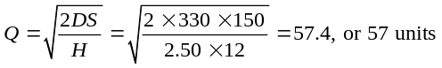  where D = period demand, S = setup or order cost, H = holding cost.  Reorder point:
 | Level: |  | Parent: |  |  |  |  |  | Quantity:
 | Item: |  | Lead Time: 1 |  |  |  |  |  | Lot Size: EOQ
 | Week No. |  | 1 | 2 | 3 | 4 | 5 | 6 | 7 | 8 | 9 | 10 | 11 | 12
 | Gross requirement |  | 30 |  | 40 |  | 30 | 70 | 20 |  | 10 | 80 |  | 50
 | Scheduled receipt
 | On hand | 40 | 40 | 10 | 10 | 27 | 27 | 54 | 41 | 21 | 21 | 11 | 45 | 45 | 52
 | Net requirement |  | 0 |  | 30 |  | 3 | 16 |  |  |  | 69 |  | 5
 | Planned order
 | receipt |  |  |  | 57 |  | 57 | 57 |  |  |  | 114 |  | 57
 | Planned order
 | release |  |  | 57 |  | 57 | 57 |  |  |  | 114 |  | 57

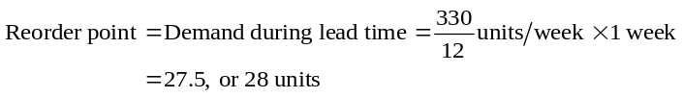

Setups: 5 × 150 = $750
Holding: (allowing for 12 time periods) 2.50 × 352 = $880
Setup + holding = total cost = $1,630

Theoretical total cost:
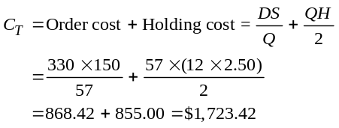
Note: Order and carrying costs are not equal due to rounding of the EOQ to a whole number. Actual total cost:
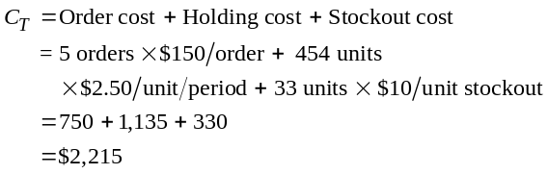
Note: The actual cost of using the EOQ policy under this case of varying demand is more than the theoretical cost. In addition, we were forced to use backorders when stockouts occurred. The poor performance with respect to stockout is due to the fact that “average demand during lead time” is not a particularly good measure of the necessary reorder point.
Note that the present versions of the Excel OM and POM for Windows software do not consider reorder points, stockouts, or backorder costs.
You may wish to make use of the following:
EOQ ordering policy, modified for delayed order placement:

Total inventory = 10 + 10 + 27 + 27 + 54 + 21 + 21 + 68 = 238
Actual total cost:
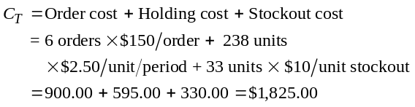

Thus, if we are able to “time” order placement in an optimal fashion, the EOQ ordering policy can be made more efficient. Note, however, that this optimal timing requires that we accurately forecast demand—something that for varying demand we are usually unable to do. Note, also, that this “optimal” timing does not reduce the likelihood of a stockout and, by increasing the customer “wait” period, may contribute to additional customer dissatisfaction. The elimination of stockouts can only be accomplished by using a higher reorder point (reorder + safety stock).
 | Week
 | 1 | 2 | 3 | 4 | 5 | 6 | 7 | 8 | 9 | 10 | 11 | 12
Gross requirement | 30 |  | 40 |  | 30 | 70 | 20 |  | 10 | 80 |  | 50
Beginning inventory | 40 | 0 | 67 | 27 | 84 | 54 | –16 | 21 | 78 | 68 | –12 | –12
Ending inventory | 10 | 10 | 27 | 27 | 54 | –16* | 21 | 21 | 68 | –12* | –12 | –5*
Order receipts |  |  | 57 |  | 57 |  | 57 |  | 57 |  |  | 57
Order release |  | 57 |  | 57 |  | 57 |  | 57 |  |  | 57 | 57
* Stockouts = 16 + 12 + 5 = 33
EOQ ordering policy, modified to include safety stock:
 |  |  |  | Week
 | 1 | 2 | 3 | 4 | 5 | 6 | 7 | 8 | 9 | 10 | 11 | 12
Gr req | 30 |  | 40 |  | 30 | 70 | 20 |  | 10 | 80 |  | 50
Beg inv | 40 | 10 | 67 | 84 | 84 | 54 | 41 | 78 | 78 | 68 | 45 | 102
End inv | 10 | 67 | 84 | 84 | 54 | 41 | 78 | 78 | 68 | 45 | 102 | 52
Ord rcpt |  | 57 | 57 |  |  | 57 | 57 |  |  | 57 | 57
Ord rel | 57 | 57 |  |  | 57 | 57 |  |  | 57 | 57 |  | 57

Reorder when ending inventory <70
Combined reorder + safety stock:
Demand
during |  |  | Cumulative
Lead Time | Frequency | Probability | Probability
0 | 4 | 0.333 | 0.333
10 | 1 | 0.083 | 0.417
20 | 1 | 0.083 | 0.500
30 | 2 | 0.167 | 0.667
40 | 1 | 0.083 | 0.750
50 | 1 | 0.083 | 0.833
60 | 0 | 0.000 | 0.833
70 | 1 | 0.083 | 0.917
80 | 1 | 0.083 | 1.000

To reduce the likelihood of a stockout to approximately 10%, we must use a combined reorder point/safety stock of 70 units. Note that this “reorder” point is approximately two and one half times the reorder point calculated using the measure of “average demand over lead time.”
Actual total cost:
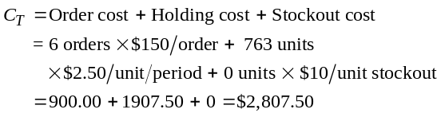

Note that as we might expect, the holding cost has increased.

14.19 Solution with lead time = 1: Holding cost = $2.50; Setup cost = $150. PPB ordering policy:
 | Week
 | 1 | 2 | 3 | 4 | 5 | 6 | 7 | 8 | 9 | 10 | 11 | 12
Gr req | 30 |  | 40 |  | 30 | 70 | 20 |  | 10 | 80 |  | 50
Beg inv | 40 | 10 | 10 | 30 | 30 | 0 | 30 | 10 | 10 | 0 | 50 | 50
End inv | 10 | 10 | 30 | 30 | 0 | 30 | 10 | 10 | 0 | 50 | 50 | 0
Ord rcpt |  |  | 60 |  |  | 100 |  |  |  | 130
Ord rel |  | 60 |  |  | 100 |  |  |  | 130
Calculating EPP:
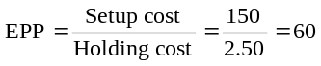

Periods | Cumulative |  |  | Costs
Combined | Net Req. |  | Part Periods | Order Hold
1 | 0 |  |  | 0 | + | 25
1, 2 | 0 |  |  | 0 | + | 25
1, 2, 3 | 30 |  |  | 150 | + | 75
1, 2, 3, 4 | 30 |  |  | 150 | + | 75
1, 2, 3, 4, 5* | 60 | 30 × 0 + 30 × 2 = 60 |  | 150
1, 2, 3, 4, 5, 6 | 130 | 30 × 0 + 30 × 2 + 70 × 3 = 270 |  | 150
* The part periods for an order encompassing periods 1, 2, 3, 4, and 5 most nearly approximates the EPP of 60.
Note: (1) We have assumed that: (a) a product ordered during a calendar week is available at the beginning of the following week; (b) shipments during a week take place at the beginning of the week. (2) POM for Windows will produce the same answer. Excel OM will produce the same answer when lead time is zero.

Periods | Cumulative |  |  | Costs
Combined | Net Req. | Part Periods | Order |  |  | Hold
6 | 70 | 70 × 0 = 0 | 150 |  | + | 0
6, 7 | 90 | 70 × 0 + 20 × 1 = 20 |  |  |  | 50
6, 7, 8 | 90 | 70 × 0 + 20 × 1 = 20 |  |  |  | 50
6, 7, 8, 9* | 100 | 70 × 0 + 20 × 1 + 10 × 3 = 50 |  |  |  | 125
6, 7, 8, 9, 10 | 180 | 70 × 0 + 20 × 1 + 10 × 3 + 80 × 4 = 370
* The part periods for an order encompassing periods 6, 7, 8, and 9 most nearly approximates the EPP of 60.
Periods | Cumulative |  |  | Costs
Combined | Net Req. | Part Periods | Order |  |  | Hold
10 | 80 | 80 × 0 = 0 | 150 |  | + | 0
10, 11 | 80 | 80 × 0 = 0 |  |  |  | 0
10, 11, 12* | 130 | 80 × 0 + 50 × 2 = 100 |  |  |  | 250
* The part periods for an order encompassing periods 10, 11, 12 most nearly approximates the EPP of 60.

Calculate total cost:
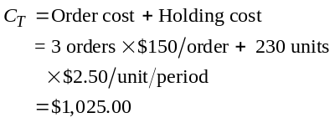

14.20 Always order 100 units; fixed order quantity (FOQ) = 100
 |  | 1 | 2 | 3 | 4 | 5 | 6 | 7 | 8 | 9 | 10
Gross requirement |  | 35 | 30 | 40 | 0 | 10 | 40 | 30 | 0 | 30 | 55
Scheduled receipt
Projected on hand | 35 | 35 | 0 | 70 | 30 | 30 | 20 | 80 | 50 | 50 | 20
Net requirement |  | 0 | 30 | 0 | 0 | 0 | 20 | 0 | 0 | 0 | 35
Planned order receipt |  |  | 100 |  |  |  | 100 |  |  |  | 100
Planned order release |  | 100 |  |  |  | 100 |  |  |  | 100
3 setups at $100 each + 350 units @ $1 = $650.
14.21 Periodic order quantity (POQ)—3 periods; Every three weeks, order for 3 wks ahead.
 |  | 1 | 2 | 3 | 4 | 5 | 6 | 7 | 8 | 9 | 10
Gross requirement |  | 35 | 30 | 40 | 0 | 10 | 40 | 30 | 0 | 30 | 55
Scheduled receipt
Projected on hand | 35 | 35 | 0 | 40 | 0 | 0 | 70 | 30 | 0 | 85 | 55
Net requirement |  | 0 | 30 | 0 | 0 | 10 | 0 | 0 | 0 | 30 | 0
Planned order receipt |  |  | 70 |  |  | 80 |  |  | 85
Planned order release |  | 70 |  |  | 80 |  |  | 85
3 setups each at $100 + 280 units @ $1 = 580
14.22 A modification of the part-period balancing shown in the text yields the following costs:
 |  | 1 | 2 | 3 | 4 | 5 | 6 | 7 | 8 | 9 | 10
Gross requirement |  | 35 | 30 | 40 | 0 | 10 | 40 | 30 | 0 | 30 | 55
Scheduled receipt
Projected on hand | 35 | 35 | 0 | 50 | 10 | 10 | 0 | 30 | 0 | 0 | 55
Net requirement |  | 0 | 30 | 0 | 0 | 0 | 40 | 30 | 0 | 30 | 0
Planned order receipt |  |  | 80 |  |  |  | 70 | 0 |  | 85
Planned order release |  | 80 |  |  |  | 70 |  |  | 85
3 setups each at $300 + 155 units @ $1 = $455
14.23 The firm has 22,500 minutes available to produce 330 units, which require 21,450 minutes of work. One possible solution is:
 |  | Capacity | Capacity
 |  | Required | Available | Over/
Week | Units | (Time) | (Time) | (Under) | Production Scheduler’s Action
1 | 0 | 0 | 2,250 | (2,250)
2 | 40 | 2,600 | 2,250 | 350 | Lot split. Use 350 minutes in week 1.
3 | 30 | 1,950 | 2,250 | (300)
4 | 40 | 2,600 | 2,250 | 350 | Lot split. Use 300 minutes in week 3. Use 50 minutes on another machine or in week 1 or 5.
5 | 10 | 650 | 2,250 | (1,600)
6 | 70 | 4,550 | 2,250 | 2,300 | Lot split. Use 1900 minutes in week 1. Operations split. Use 400 minutes on another machine, overtime, or subcontract.
7 | 40 | 2,600 | 2,250 | 350 | Overlap operations so that next operation can begin. Lot split. Use 350 minutes in week 5.
8 | 10 | 650 | 2,250 | (1,600)
9 | 30 | 1,950 | 2,250 | (300)
10 | 60 | 3,900 | 2,250 | 1,650 | Lot split. 1250 minutes in Week 8 and 300 minutes in  week 9. Operations split. 100 minutes on another machine, overtime, or subcontract.
There are other possible solutions.

14.24
 |  | Capacity | Capacity
 |  | Required | Available | Over/
Week | Units | (Time) | (Time) | (Under) | Production Scheduler’s Action
1 | 60 | 3,900 | 2,250 | 1,650 | Lot split. Move 300 minutes (4.3 units) to week 2 and 1350
 |  |  |  |  | minutes to week 3.
2 | 30 | 1,950 | 2,250 | (300)
3 | 10 | 650 | 2,250 | (1,600)
4 | 40 | 2,600 | 2,250 | 350 | Lot split. Move 250 minutes to week 3. Operation split.
 |  |  |  |  | Move 100 minutes to another machine, overtime, or subcontract.
5 | 70 | 4,550 | 2,250 | 2,300 | Lot split. Move 1600 minutes to week 6. Overlap operations
 |  |  |  |  | to get product out door. Operations split. Move 700 minutes
 |  |  |  |  | to another machine, overtime, or subcontract.
6 | 10 | 650 | 2,250 | (1,600)
7 | 40 | 2,600 | 2,250 | 300 | Lot split. Move 300 minutes to week 8. Overlap operations
 |  |  |  |  | to get product out the door.
8 | 30 | 1,950 | 2,250 | (300)
9 | 40 | 2,600 | 2,250 | 350 | Lot split. Move 350 minutes to week 10. Overlap operations
 |  |  |  |  | to get product out the door.
10 | 0 | 0 | 2,250 | (2,250) | 1950 available minutes. Look at next week for early production.
There are other possible solutions.

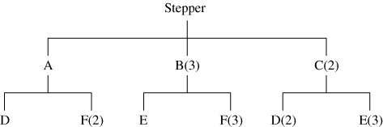

14.25 (a)

(b)

(c)
Stepper | 1 | 2 | 3 | 4 | 5 | 6 | 7 | 8
Gross requirement |  |  |  |  |  |  |  | 50
On hand 20 |  |  |  |  |  |  |  | 20
Net |  |  |  |  |  |  |  | 30
P.O. receipt |  |  |  |  |  |  |  | 30
P.O. release |  |  |  |  |  | 30
A | 1 | 2 | 3 | 4 | 5 | 6 | 7 | 8
Gross requirement |  |  |  |  |  | 30
On hand 10 |  |  |  |  |  | 10
Net |  |  |  |  |  | 20
P.O. receipt |  |  |  |  |  | 20
P.O. release |  |  |  |  | 20

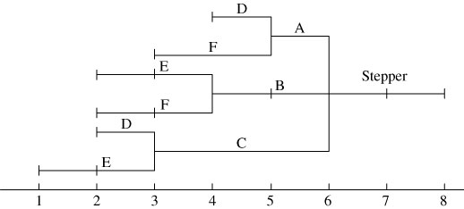

B | 1 | 2 | 3 | 4 | 5 | 6 | 7 | 8
Gross requirement |  |  |  |  |  | 90
On hand 30 |  |  |  |  |  | 30
Net |  |  |  |  |  | 60
P.O. receipt |  |  |  |  |  | 60
P.O. release |  |  |  | 60
F | 1 | 2 | 3 | 4 | 5 | 6 | 7 | 8
Gross requirement |  |  |  | 180 | 40
On hand 20 |  |  |  | 20 | 0
Net |  |  |  | 160 | 40
P.O. receipt |  |  |  | 160 | 40
P.O. release |  | 160 | 40

14.26
Lot  Size | Lead Time  (# of periods) | On Hand | Safety Stock | Allocated | Low-Level Code | Item ID |  |  | Period (day)
 |  |  |  |  |  |  |  |  | 1 | 2 | 3 | 4 | 5 | 6 | 7 | 8
Lot for Lot | 1 | — | — | — | 0 | Table | Gross requirement |  |  |  |  |  | 640 | 640 | 128 | 128
Lot for Lot |  |  |  |  |  | Table | Scheduled receipt
Lot for Lot |  |  |  |  |  | Table | Projected on hand
Lot for Lot |  |  |  |  |  | Table | Net requirement |  |  |  |  |  | 640 | 640 | 128 | 128
Lot for Lot |  |  |  |  |  | Table | Planned order receipt |  |  |  |  |  | 640 | 640 | 128 | 128
Lot for Lot |  |  |  |  |  | Table | Planned order release |  |  |  |  | 640 | 640 | 128 | 128
Lot for Lot | 1 | — | — | — | 1 | Top | Gross requirement |  |  |  |  | 640 | 640 | 128 | 128
Lot for Lot |  |  |  |  |  | Top | Scheduled receipt
Lot for Lot |  |  |  |  |  | Top | Projected on hand
Lot for Lot |  |  |  |  |  | Top | Net requirement |  |  |  |  | 640 | 640 | 128 | 128
Lot for Lot |  |  |  |  |  | Top | Planned order receipt |  |  |  |  | 640 | 640 | 128 | 128
Lot for Lot |  |  |  |  |  | Top | Planned order release |  |  |  | 640 | 640 | 128 | 128
Lot for Lot  gallons | 1 | — | — | — | 1 | Stain (gal.) | Gross requirement |  |  |  |  | 80 | 80 | 16 | 16
Lot for Lot  gallons |  |  |  |  |  | Stain (gal.) | Scheduled receipt
Lot for Lot  gallons |  |  |  |  |  | Stain (gal.) | Projected on hand
Lot for Lot  gallons |  |  |  |  |  | Stain (gal.) | Net requirement |  |  |  |  | 80 | 80 | 16 | 16
Lot for Lot  gallons |  |  |  |  |  | Stain (gal.) | Planned order receipt |  |  |  |  | 80 | 80 | 16 | 16
Lot for Lot  gallons |  |  |  |  |  | Stain (gal.) | Planned order release |  |  |  | 80 | 80 | 16 | 16
Lot for Lot  gallons | 1 | — | — | — | 1 | Glue (gal.) | Gross requirement |  |  |  |  | 40 | 40 | 8 | 8
Lot for Lot  gallons |  |  |  |  |  | Glue (gal.) | Scheduled receipt
Lot for Lot  gallons |  |  |  |  |  | Glue (gal.) | Projected on hand | 100 | 100 | 100 | 100 | 100 | 60 | 20 | 12 | 4
Lot for Lot  gallons |  | 100 |  |  |  | Glue (gal.) | Net requirement
Lot for Lot  gallons |  |  |  |  |  | Glue (gal.) | Planned order receipt
Lot for Lot  gallons |  |  |  |  |  | Glue (gal.) | Planned order release
Lot for Lot | 1 | — | — | — | 1 | Base | Gross requirement |  |  |  |  | 640 | 640 | 128 | 128
Lot for Lot |  |  |  |  |  | Base | Scheduled receipt
Lot for Lot |  |  |  |  |  | Base | Projected on hand
Lot for Lot |  |  |  |  |  | Base | Net requirement |  |  |  |  | 640 | 640 | 128 | 128
Lot for Lot |  |  |  |  |  | Base | Planned order receipt |  |  |  |  | 640 | 640 | 128 | 128
Lot for Lot |  |  |  |  |  | Base | Planned order release |  |  |  | 640 | 640 | 128 | 128
Lot for Lot | 1 | — | — | — | 2 | Short Brace | Gross requirement |  |  |  | 1,280 | 1,280 | 256 | 256
Lot for Lot |  |  |  |  |  | Short Brace | Scheduled receipt
Lot for Lot |  |  |  |  |  | Short Brace | Projected on hand
Lot for Lot |  |  |  |  |  | Short Brace | Net requirement |  |  |  | 1,280 | 1,280 | 256 | 256
Lot for Lot |  |  |  |  |  | Short Brace | Planned order receipt |  |  |  | 1,280 | 1,280 | 256 | 256
Lot for Lot |  |  |  |  |  | Short Brace | Planned order release |  |  | 1,280 | 1,280 | 256 | 256
Continued

Lot for Lot | 1 | — | — | — | 2 | Long Brace | Gross requirement |  |  |  | 1,280 | 1,280 | 256 | 256
Lot for Lot |  |  |  |  |  | Long Brace | Scheduled receipt
Lot for Lot |  |  |  |  |  | Long Brace | Projected on hand
Lot for Lot |  |  |  |  |  | Long Brace | Net requirement |  |  |  | 1,280 | 1,280 | 256 | 256
Lot for Lot |  |  |  |  |  | Long Brace | Planned order receipt |  |  |  | 1,280 | 1,280 | 256 | 256
Lot for Lot |  |  |  |  |  | Long Brace | Planned order release |  |  | 1,280 | 1,280 | 256 | 256
Lot for Lot | 1 | — | — | — | 2 | Leg | Gross requirement |  |  |  | 2,560 | 2,560 | 512 | 512
Lot for Lot |  |  |  |  |  | Leg | Scheduled receipt
Lot for Lot |  |  |  |  |  | Leg | Projected on hand
Lot for Lot |  |  |  |  |  | Leg | Net requirement |  |  |  | 2,560 | 2,560 | 512 | 512
Lot for Lot |  |  |  |  |  | Leg | Planned order receipt |  |  |  | 2,560 | 2,560 | 512 | 512
Lot for Lot |  |  |  |  |  | Leg | Planned order release |  |  | 2,560 | 2,560 | 512 | 512

Lot for Lot | 1 | — | — | — | 3 | Brass Caps | Gross requirement |  |  | 2,560 | 2,560 | 512 | 512
Lot for Lot |  |  |  |  |  | Brass Caps | Scheduled receipt
Lot for Lot |  |  |  |  |  | Brass Caps | Projected on hand |  |  |  | 440 | 880 | 368 | 856 | 856 | 856
Lot for Lot |  |  |  |  |  | Brass Caps | Net requirement |  |  | 2,560 | 2,120 |  | 144
Lot for Lot |  |  |  |  |  | Brass Caps | Planned order receipt |  |  | 3,000 | 3,000 |  | 1,000
Lot for Lot | 1000 Min Lot Size |  |  |  |  | Brass Caps | Planned order release |  | 3,000 | 3,000 |  | 1,000

14.27 | Coffee Table  Master Schedule | Hrs  Required | Lead Time | Day 1 | Day 2 | Day 3 | Day 4 | Day 5 | Day 6 | Day 7 | Day 8
 |  |  |  |  |  |  |  | 640 | 640 | 128 | 128
 | Table Assembly | 2 | 1 |  |  |  | 1,280 | 1,280 | 256 | 256
 | Top Preparation | 2 | 1 |  |  | 1,280 | 1,280 | 256 | 256
 | Assemble Base | 1 | 1 |  |  | 640 | 640 | 128 | 128
 | Long Brace (2) | 0.25 | 1 |  | 320 | 320 | 64 | 64
 | Short Brace (2) | 0.25 | 1 |  | 320 | 320 | 64 | 64
 | Leg (4) | 0.25 | 1 |  | 640 | 640 | 128 | 128
 | Total Hours |  |  | 0 | 1,280 | 3,200 | 3,456 | 1,920 | 640 | 256
 | Employees need @ 8 hrs. each |  |  | 0 | 160 | 400 | 432 | 240 | 80 | 32

Additonal Homework Problems
Here are solutions to additional homework problems 14.28–14.32 that appear on our Web site, www.myomlab.com.
14.28 (a)
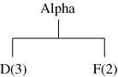

(b)
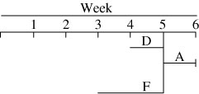

(c)
Week 1 | 2 | 3 | 4 | 5 | 6
Required Date |  |  |  |  | 10
Order Release |  |  |  | 10 |  | A
Required Date |  |  |  | 30
Order Release |  |  | 30 |  |  | D
Required Date |  |  |  | 20
Order Release |  | 20 |  |  |  | F

14.29
Level: 0 |  | Parent: — |  |  |  |  | Quantity:
Item: A |  | Lead Time: 1 week |  |  |  |  | Lot Size: L4L
Week No. |  | 1 | 2 | 3 | 4 | 5 |  | 6 | 7 | 8 | 9 | 10
Gross requirement |  |  |  |  |  |  |  | 10
Scheduled receipt
On hand 2 |  | 2 | 2 | 2 | 2 | 2 |  | 2
Net requirement |  |  |  |  |  |  |  | 8
Planned order receipt |  |  |  |  |  |  |  | 8
Planned order release |  |  |  |  |  | 8

Level: 1 | Parent: A |  |  |  |  | Quantity: 3
Item: D | Lead Time: 1 week |  |  |  |  | Lot Size: L4L
Week No. | 1 | 2 | 3 | 4 | 5 |  | 6 | 7 | 8 | 9 | 10
Gross requirement |  |  |  |  | 24
Scheduled receipt
On hand 4 | 4 | 4 | 4 | 4 | 4
Net requirement |  |  |  |  | 20
Planned order receipt |  |  |  |  | 20
Planned order release |  |  |  | 20

Level: 1 | Parent: A |  |  |  |  | Quantity: 2
Item: F | Lead Time: 2 weeks |  |  |  |  | Lot Size: L4L
Week No. | 1 | 2 | 3 | 4 | 5 |  | 6 | 7 | 8 |  | 9 | 10
Gross requirement |  |  |  |  | 16
Scheduled receipt
On hand | 0 | 0 | 0 | 0 | 0
Net requirement |  |  |  |  | 16
Planned order receipt |  |  |  |  | 16
Planned order release |  |  | 16

14.30 (a)
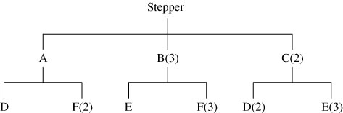

(b)
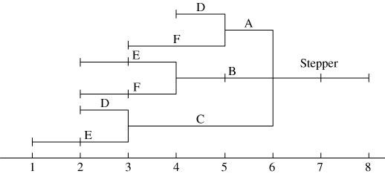

14.30 (c)
Stepper | 1 | 2 | 3 | 4 | 5 | 6 | 7 | 8
Gross requirement |  |  |  |  |  |  |  | 50
On hand 20 |  |  |  |  |  |  |  | 20
Net |  |  |  |  |  |  |  | 30
P.O. receipt |  |  |  |  |  |  |  | 30
P.O. release |  |  |  |  |  | 30
A | 1 | 2 | 3 | 4 | 5 | 6 | 7 | 8
Gross requirement |  |  |  |  |  | 30
On hand 10 |  |  |  |  |  | 10
Net |  |  |  |  |  | 20
P.O. receipt |  |  |  |  |  | 20
P.O. release |  |  |  |  | 20
B | 1 | 2 | 3 | 4 | 5 | 6 | 7 | 8
Gross requirement |  |  |  |  |  | 90
On hand 30 |  |  |  |  |  | 30
Net |  |  |  |  |  | 60
P.O. receipt |  |  |  |  |  | 60
P.O. release |  |  |  | 60

F |  | 1 | 2 | 3 | 4 | 5 | 6 | 7 | 8
Gross requirement |  |  |  |  | 180 | 40
On hand 20 |  |  |  |  | 20 | 0
Net |  |  |  |  | 160 | 40
P.O. receipt |  |  |  |  | 160 | 40
P.O. release |  |  | 160 | 40

14.31 (a) Economic Order Quantity
 | Week
 | Now | 1 | 2 | 3 | 4 | 5 | 6 | 7 | 8 | 9 | 10
Gr req |  | 35 | 30 | 45 | 0 | 10 | 40 | 30 | 0 | 30 | 55
Beg inv | 0 | 0 | 70 | 40 | –5 | 100 | 90 | 50 | 20 | 125 | 95
End inv | 0* | 70 | 40 | –5* | 100 | 90 | 50 | 20* | 125 | 95 | 40
Ord rcpt |  | 105 |  |  | 105 |  |  |  | 105
Ord rel | 105 |  |  | 105 |  |  |  | 105

Note: If the five units not produced in period 3 (because of five-unit shortage) are produced in week 4, then actual inventory drops by five units (from 680 to 675). This analysis includes holding cost for the 40 units held from period 10 for period 11.
Orders are placed in the weeks with ending inventory below the reorder point (i.e. 27.5) as noted with
asterisks.
Economic Order Quantity:
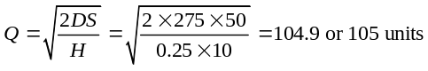
where D = period demand, S = setup or order cost,
H = holding cost.
Reorder point:
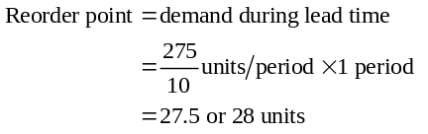
Theoretical total cost:
Periods | Cumulative |  | Costs
Combined | Net Req. | Part Periods | Order | Hold
1 | 35 | 0 = 0 | 50 | + 0.00
1, 2 | 65 | 30 × 1 = 30 |  | 21.25
1, 2, 3 | 110 | 30 × 1 + 45 × 2 = 120 |  | 13.75
1, 2, 3, 4 | 110 | 30 × 1 + 45 × 2 + 0 × 3 = 120 |  | 2.50
1, 2, 3, 4, 5* | 120 | 30 × 1 + 45 × 2 + 10 × 4 = 160 |  | 2.50
1, 2, 3, 4, 5, 6 | 160 | 30 × 1 + 45 × 2 + 10 × 4 + 40 × 5 = 360
* The part periods for an order encompassing periods 1, 2, 3, 4, and 5, most nearly approximates the EPP of 200.
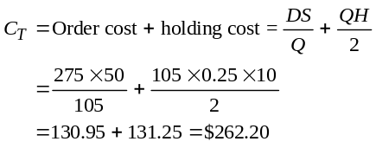
Note: Order and carrying costs are not equal due to rounding the EOQ to a whole number.
Actual cost:
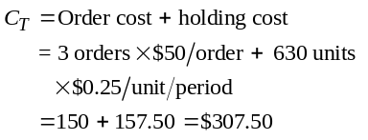

(b) Lot for Lot:
 | Week
This
week
 | This  week | 1 | 2 | 3 | 4 | 5 | 6 | 7 | 8 | 9 | 10
Gr req |  | 35 | 30 | 45 | 0 | 10 | 40 | 30 | 0 | 30 | 55
Beg inv | 0 | 0 | 0 | 0 | 0 | 0 | 0 | 0 | 0 | 0 | 0
End inv | 0 | 0 | 0 | 0 | 0 | 0 | 0 | 0 | 0 | 0 | 0
Ord rcpt |  | 35 | 30 | 45 |  | 10 | 40 | 30 |  | 30 | 55
Ord rel | 35 | 30 | 45 |  | 10 | 40 | 30 |  | 30 | 55

Calculating total cost:
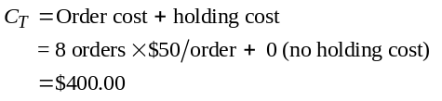
(c) Part-period balancing
 | Week
 | Now | 1 | 2 | 3 | 4 | 5 | 6 | 7 | 8 | 9 | 10
Gr req |  | 35 | 30 | 45 | 0 | 10 | 40 | 30 | 0 | 30 | 55
Beg inv | 0 | 0 | 85 | 55 | 10 | 10 | 0 | 60 | 30 | 30 | 0
End inv | 0 | 85 | 55 | 10 | 10 | 0 | 60 | 30 | 30 | 0 | 0
Ord rcpt |  | 120 |  |  |  |  | 100 |  |  |  | 55
Ord rel | 120 |  |  |  |  | 100 |  |  |  | 55

Calculating EPP:
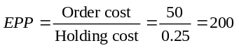

Note: (1) We have assumed that: (a) a product ordered during a calendar week is available at the beginning of the following week; (b) shipments during a week take place at the beginning of the week; (c) no carrying cost occurs during the week the order is received.
(2) The POM for Windows program is unable to
handle the non-zero lead-time—thus will produce a different answer. Excel OM does not perform Part-Period balancing.

Periods | Cumulative |  | Costs
Combined | Net Req. | Part Periods | Order | Hold
6 | 40 | 40 × 0 = | 50 | + 15.00
6, 7 | 70 | 40 × 0 + 30 × 1 = 30 |  | 7.50
6, 7, 8 | 70 | 40 × 0 + 30 × 1 = 30 |  | 7.50
6, 7, 8, 9* | 100 | 40 × 0 + 30 × 1 + 30 × 3 = 120
6, 7, 8, 9, 10 | 155 | 40 × 0 + 30 × 1 + 30 × 3 + 55 × 4 = 340
* The part periods for an order encompassing periods 6, 7, 8, and 9, most nearly approximates the
EPP of 200. The last period with a demand of 55 units will also require an order of 55 units.

Calculating total cost:
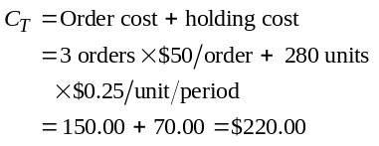
14.32

 |  |  |  |  |  |  | Item A
Week | 1 | 2 | 3 | 4 | 5 | 6 | 7 | 8 | 9 | 10 | 11 | 12 | 13 | 14 | 15 | 16
Total req. |  |  |  |  |  |  |  | 10 |  |  |  | 10 |  |  | 5
On hand | 3 | 3 | 3 | 3 | 3 | 3 | 3 | 3 |  |  |  | — |  |  | —
Net req. |  |  |  |  |  |  |  | 7 |  |  |  | 10 |  |  | 5
Ord rec. |  |  |  |  |  |  |  | 7 |  |  |  | 10 |  |  | 5
Ord rel. |  |  |  |  |  |  | 7 |  |  |  | 10 |  |  | 5

 |  |  |  |  |  |  | Item B
Week | 1 | 2 | 3 | 4 | 5 | 6 | 7 | 8 | 9 | 10 | 11 | 12 | 13 | 14 | 15 | 16
Total req. |  |  |  |  |  | 10 | 7 |  |  |  | 10 |  |  | 5 |  | 3
On hand | 2 | 2 | 2 | 2 | 2 | 2 | 2 | — |  |  | — |  |  | — |  | —
Net req. |  |  |  |  |  | 8 | 7 |  |  |  | 10 |  |  | 5 |  | 3
Ord rec. |  |  |  |  |  | 8 | 7 |  |  |  | 10 |  |  | 5 |  | 3
Ord rel. |  |  |  |  | 8 | 7 |  |  |  | 10 |  |  | 5 |  | 3

 |  |  |  |  |  |  | Item C
Week | 1 | 2 | 3 | 4 | 5 | 6 | 7 | 8 | 9 | 10 | 11 | 12 | 13 | 14 | 15 | 16
Total req. |  |  |  |  | 10 | 7 |  |  | 10 | 10 |  | 5 | 5 |  | 3
On hand | 10 | 10 | 10 | 10 | 10 | — |  |  | — | — |  | — | — |  | —
Net req. |  |  |  |  |  | 7 |  |  | 10 | 10 |  | 5 | 5 |  | 3
Ord rec. |  |  |  |  |  | 7 |  |  | 10 | 10 |  | 5 | 5 |  | 3
Ord rel. |  |  |  | 7 |  |  | 10 | 10 |  | 5 | 5 |  | 3

 |  |  |  |  |  |  | Item D
Week | 1 | 2 | 3 | 4 | 5 | 6 | 7 | 8 | 9 | 10 | 11 | 12 | 13 | 14 | 15 | 16
Total req. |  |  |  |  | 8 | 7 |  |  |  | 10 |  |  | 5 |  | 3
On hand | 5 | 5 | 5 | 5 | 5 | — |  |  |  | — |  |  | — |  | —
Net req. |  |  |  |  | 3 | 7 |  |  |  | 10 |  |  | 5 |  | 3
Ord rec. |  |  |  |  | 3 | 7 |  |  |  | 10 |  |  | 5 |  | 3
Ord rel. |  |  |  | 3 | 7 |  |  |  | 10 |  |  | 5 |  | 3

 |  |  |  |  |  |  | Item E
Week | 1 | 2 | 3 | 4 | 5 | 6 | 7 | 8 | 9 | 10 | 11 | 12 | 13 | 14 | 15 | 16
Total req. |  |  |  | 3 | 9 |  |  |  | 20 |  |  | 10 |  | 3
On hand | 5 | 5 | 5 | 5 | 2 |  |  |  | — |  |  | — |  | —
Net req. |  |  |  |  | 7 |  |  |  | 20 |  |  | 10 |  | 3
Ord rec. |  |  |  |  | 7 |  |  |  | 20 |  |  | 10 |  | 3
Ord rel. |  |  |  | 7 |  |  |  | 20 |  |  | 10 |  | 3

 |  |  |  |  |  |  | Item F
Week | 1 | 2 | 3 | 4 | 5 | 6 | 7 | 8 | 9 | 10 | 11 | 12 | 13 | 14 | 15 | 16
Total req. |  |  |  |  |  | 10 | 7 |  |  |  | 10 |  |  | 5
On hand | 5 | 5 | 5 | 5 | 5 | 5 | — |  |  |  | — |  |  | —
Net req. |  |  |  |  |  | 5 | 7 |  |  |  | 10 |  |  | 5
Ord rec. |  |  |  |  |  | 5 | 7 |  |  |  | 10 |  |  | 5
Ord rel. |  |  |  |  | 5 | 7 |  |  |  | 10 |  |  | 5

 |  |  |  |  |  |  | Item G
Week | 1 | 2 | 3 | 4 | 5 | 6 | 7 | 8 | 9 | 10 | 11 | 12 | 13 | 14 | 15 | 16
Total req. |  |  |  |  | 5 | 7 |  |  |  | 10 |  |  | 5
On hand | 1 | 1 | 1 | 1 | 1 | — |  |  |  | — |  |  | —
Net req. |  |  |  |  | 4 | 7 |  |  |  | 10 |  |  | 5
Ord rec. |  |  |  |  | 4 | 7 |  |  |  | 10 |  |  | 5
Ord rel. | 4 | 7 |  |  |  | 10 |  |  | 5

 |  |  |  |  |  |  | Item H
Week | 1 | 2 | 3 | 4 | 5 | 6 | 7 | 8 | 9 | 10 | 11 | 12 | 13 | 14 | 15 | 16
Total req. |  |  |  |  | 5 | 7 |  |  |  | 10 |  |  | 5
On hand | 10 | 10 | 10 | 10 | 10 | 5 |  |  |  | — |  |  | —
Net req. |  |  |  |  |  | 2 |  |  |  | 10 |  |  | 5
Ord rec. |  |  |  |  |  | 2 |  |  |  | 10 |  |  | 5
Ord rel. |  |  |  |  | 2 |  |  |  | 10 |  |  | 5

Case Study
HILL’S AUTOMOTIVE, INC.
In this case, each department argues that it is doing its job well—“the problem is with them.” The result is confusion and poor results for the company as a whole. Many of the problems relate to the classic MRP issues of (a) lack of master schedule; (b) lack of capacity planning; and (c) few, if any, accurate lead times, all resulting in poor scheduling and chaos in the assembly area. There seems also to be a question as to whether the various departments are working
toward common goals and whether appropriate measures of performance are in place. The specific issues in a plan would include (a) introduction of corporate wide goals and performance measures for each function; (b) development of labor standards for the assembly, and packaging operations; (c) development of quality standards for all production and purchased items, to which suppliers would adhere; (d) improvements in inventory management practices; (e) development of a capacity planning procedure (i.e., determination as to how many units can be produced during what time periods); (f) implementation of a master production schedule (which might encompass a relatively short horizon due to the typical short production cycle); and, ultimately, proper use of an
MRP system. When this is completed, everyone will be judged by corporate-based performance measures, using common information, in working toward common goals.

2. A properly used MRP system will provide the structure needed at Hill’s Automotive; unneeded and excess inventory and poor bills of material will be evident, as will production schedules beyond the firm’s capabilities. Lead times, order release dates, shortages, etc. will also be specified. Accuracy and discipline will be required.
The instructor may then want to discuss the problems one would encounter in implementing some of the changes discussed above. As a beginning, one might consider that the individual departments appear to be operating in a relatively informal manner and as separate entities. The student might be asked to consider how the persons employed within this organization will react to the changes suggested above, which, uniformly, result in increased demands on employees and increased integration among departments.
Video Case Study
MRP AT WHEELED COACH
A 7-minute video, filmed specifically for this text, is available from Prentice Hall and is designed to supplement the written case.
1. Accurate inventory is an important issue at Wheeled Coach because of the dynamic changes that occur in ambulances. Items that are purchased but not used promptly often end up as excess inventory and must be disposed of at distress prices. Moreover, MRP does not work without accurate inventory. As in any dependent manufacturing process, shortage of a part may mean that the entire end unit, in this case an expensive ambulance, cannot be assembled, completed, or delivered. Accurate inventory has cost implications for both the units in which the inventory is to be installed (the ambulance) and as an asset.
2. Excess inventory exists because of minimum order requirements, BOM errors, customer-change orders, purchasing and
receiving errors, etc. A plan for Wheeled Coach to deal with excess inventory is first to see what can be returned to the vendor for near full credit; second, see what can be substituted on subsequent units for the items called out on the bills of material; and third, work at some sort of sale or scrap or supply to other auto dealers or truckers who may have need for the items.
3. Wheeled Coach will find it difficult to dispose of excess inventory. It is hard to substitute excess components in units (and their related bills of material) as units are being assembled. It takes innovation on the part of the engineering shop and inventory personnel to make this work and keep the bills of material, through engineering changes notices, accurate. For those items that are changed but are not critical, management instituted an effectivity date. That is a date that the change would be effective to the date in the production schedule that allowed all of the components in stock to be used. Some material can be returned to the supplier, but most suppliers are not interested in taking old merchandise back, so that is a difficult option. Finally, selling the items themselves proved a reasonable last resort. However, even this is expensive. It requires cataloging, publicity, letter writing, phone calls, and follow-up. It is a real marketing challenge, and Wheeled Coach does this by having occasional sales of excess inventory on Saturdays. All of these options are being used, and all do reduce inventory ultimately.
Additional Case Study*
IKON’S ATTEMPT AT ERP
1. IKON needs comprehensive marketing information on potential customers, existing customers, and their copier installations, and then a service history on each machine sold and its owner or leaseholder. Additionally, it needs the usual accounting information on payables, receivables, assets, and liabilities as well as good inventory information on copiers, parts, and supplies.
2. The advantages of ERP software are that it is usually sold as an integrated system that ties HR, accounting, manufacturing, and suppliers together. Consequently, in theory, it provides for a high degree of timely, accurate information. Most of these systems deliver much less than the theory suggests.
The disadvantage of any standard software product is that it may not (or will not) fit a given (in this case IKON’s) business. IKON’s problem was complicated because many ERP systems are an outgrowth of manufacturing systems. This manufacturing base often means they are weak in the marketing, customer tracking, service, and repair features critical to IKON’s competitive advantage. A wide variety of special programs have been written for customer sales and service tracking, but for SAP, like other vendors in the field, that was not an initial priority.
3. The bet was that the pilot installation would work at reasonable cost and, not incidentally, do the job. This did not turn out to be the case. (It cost over $14 million to get the system running,
$8 million paid to IBM for consulting and the remainder of the $25 million paid in consulting fees since the system was turned on.)
4. The project was canceled because of the expense, combined with functionality gaps and the amount of internal business procedures IKON would have to change.

* This case study appears on our Companion Web site,
www.pearsonhighered.com/heizer.

